* The EEG signals were recorded for 5 min

in eyes-closed resting state on 14-channel (AF3, AF4, F3,

F4, F5, F6, F7, F8, T7, T8, P7, P8, O1, and O2)

* Then, the data were filtered using sixth-order Butterworth

bandpass filter with lower and higher cutoff frequencies of

1 and 49 Hz in order to reduce the artifact components.

The filtering is performed in forward and reverse, twice, to

cancel the phase nonlinearity of the butterworth filter

* signals were separated into

EEG epochs of 2 s for further processing

* Data for one group= N subjects in group x K EEG segments of 2s x C number of channels
* To calculate these bispectrum features, epochs

of 256 samples (2 s) with 50% overlap Hanning window

and record of 256 NFFT points at 128 Hz sampling rate

were used.

Use the matlab function for this



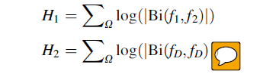

principal

domain region, Omega.



* SVM with Radial basis function (RBF)
* 10-fold cross validation